The European Assistance for Innovation Procurement launches a new call for assistance

Brussels, 03 April 2019

Sign up!

Are you a public procurer in one of the EU Member States that is interested to receive assistance in the preparation and implementation of your next innovation procurement? Sign up for the new call for assistance of the European Assistance for Innovation Procurement initiative (www.eafip.eu)

During 2019, at least 3 new Pre-Commercial Procurements (PCP) and Public Procurements of Innovative Solution (PPI) of ICT based solutions will benefit from technical and/or legal local assistance free of charge.

Especially welcome are innovation procurements of high impact ICT solutions (e.g. Blockchain, Artificial Intelligence, Cybersecurity, Virtual/Augmented reality, Big Data) and innovation procurements that are linked to national digital/ICT strategies.

Apply for assistance here: https://ec.europa.eu/eusurvey/runner/EAFIP2019

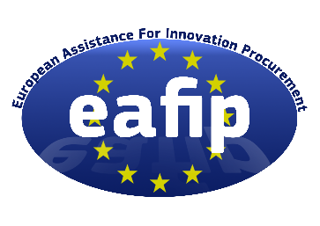
Editorial information
For more information you can contact:

Ms. Ana Lucia Jaramillo or Ms. Matty van Sloten
a.jaramillo@corvers.com m.vansloten@corvers.com
+31 6-20552773 +31 6-51775863

Corvers Procurement Services (Contractor for the European Assistance for Innovation Procurement – eafip)
Julianaplein 21, 5211 BB
‘s-Hertogenbosch
The Netherlands
www.corvers.com

Attachment: logo eafip blue w border.png

